WS# 74446 Behavior Change: The Good, the Bad and the Ugly by Sasha Long

http://bit.do/behaviorchange

QR Code:
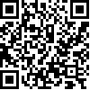
http://bit.do/behaviorchange

